Lab 11 -Loading SharePoint Data

1. Create a Webpart yo @microsoft/sharepoint
   1. 
2. Enter all details as below

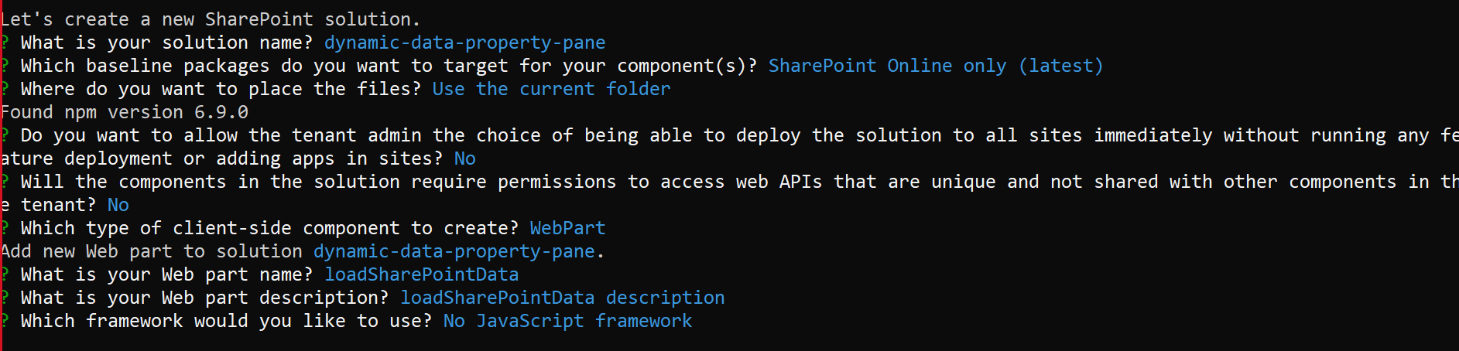

1. Import SPHttpClient

*import {SPHttpClient, SPHttpClientResponse, ISPHttpClientOptions } from '@microsoft/sp-http';*

1. Add Checkbox property pane

import {

IPropertyPaneConfiguration,

PropertyPaneTextField,

**PropertyPaneCheckbox**

} from '@microsoft/sp-property-pane';

1. Add the WebPartProps

export interface ILoadSharePointDataWebPartProps {

listname: string; (Here rename description to Listname)

checkbox1:boolean;

}

1. Add interfaces to maintain the SharePoint list data

export interface ISPListItems{

value: ISPListItem[];

}

export interface ISPListItem

{

Title: string;

Id: string;

Created: string;

}

1. Open LoadSharePointDataWebPart.module.scss file and add below css classes

.Table {

display: table;

}

.Title {

display: table-caption;

text-align: center;

font-weight: bold;

font-size: larger;

}

.Heading {

display: table-row;

font-weight: bold;

text-align: center;

}

.row {

display: table-row;

}

.cell {

display: table-cell;

border: solid;

border-width: thin;

padding-left: 5px;

padding-right: 5px;

}

1. Go to WebPart class export default class LoadSharePointDataWebPart extends BaseClientSideWebPart

Declare below variables

private listName: string = "";

private checkbox1Property: string = "Created";

1. In the render() method modify the html

<div class="${ styles.loadSharePointData }">

<div class="${styles.Table}">

<div class = "${styles.Heading}">

<div class="${styles.cell}">Title</div>

</div>

</div>

</div>

1. Get Listname from Propertypane, add below code in render method

this.listName = this.properties.listname;

1. Get Data from SharePoint list, call below method from render method

this.loadData();

1. Then add below methods, next to render method#

private loadData(): void{

let url:string = this.context.pageContext.web.absoluteUrl + "/_api/web/lists/getbytitle('" + this.listName +"')/items?select=Title";

if(this.properties.checkbox1)

{

url += ",Created";

this.domElement.querySelector("." + styles.Heading).innerHTML += `<div class="${styles.cell}">Created</div>`;

}

this.GetListData(url).then((response)=> {

this.RenderListData(response.value);

});

}

private GetListData(url:string):Promise<ISPListItems>{

return this.context.spHttpClient.get(url,SPHttpClient.configurations.v1)

.then((response:SPHttpClientResponse) =>{

return response.json();

});

}

private RenderListData(listItems:ISPListItem[]):void{

let strHtml:string = "";

if(listItems)

{

listItems.forEach((listItem:ISPListItem)=>{

let itemcreatedstr:string = listItem.Created;

let itemTime:Date = new Date(itemcreatedstr);

strHtml += `<div class="${styles.row}">`;

strHtml += `<div class="${styles.cell}"><p>${listItem.Title}</p></div>`;

if(this.properties.checkbox1)

{

strHtml += `<div class="${styles.cell}"><p>${listItem.Created}</p></div>`;

}

strHtml += `</div>`;

});

}

this.domElement.querySelector("." + styles.Table).innerHTML += strHtml;

}

1. Update the Property pane controls

Replace the groupFields

groupFields: [

PropertyPaneTextField('listname', {

label: "List Name"

}),

PropertyPaneCheckbox('checkbox1',{

text:this.checkbox1Property

})

]